# What is JSON API Collection?

**JSON API Collection** contains the All sample transactions that would generate the stimulated response from our [Virtualized Sandbox instance](https://developer.fedex.com/api/en-us/guides/sandboxvirtualization.html). Consumers can run the specific transaction per their business need & successfully integrate their code with FedEx API.

# How to find the specific transaction that would fit my business use case scenario?

* **Step 1:** Locate the “*Lookup test case Tool”* excel in the Ship API JSON Collection downloaded in your local drive.

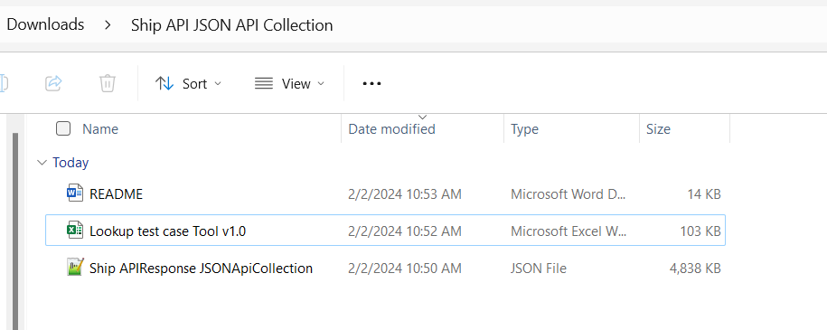

* **Step 2:** Open this file & apply the filters that would best fit your use case scenario. For example, I am looking for “US to Canada” Shipment transaction for “Hold at Location” special service.

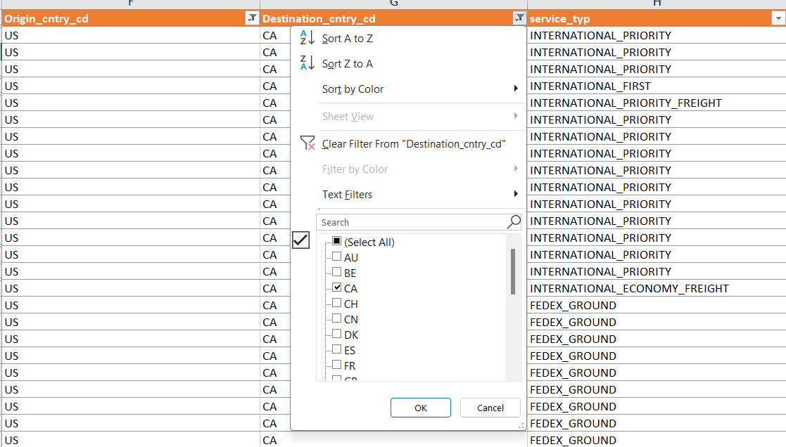

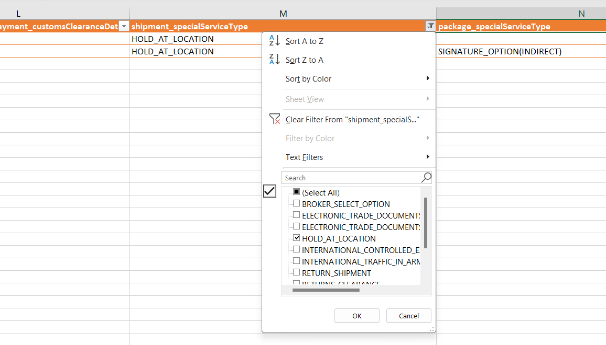

* **Step 3:** Once you apply the filter, you will get the list of transactions that match your use case scenario. Get the *key* & name from this filter.  
    
  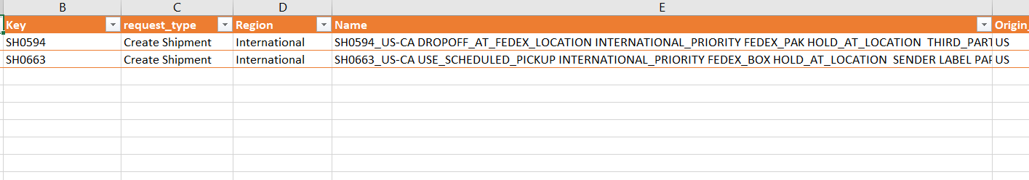For the example scenario, *keys* are “SH0594” and “SH0663” as shown above

# How to run the specific transaction in JSON API Collection?

* **Step 4:** Import the JSON API Collection into suite of your choice.

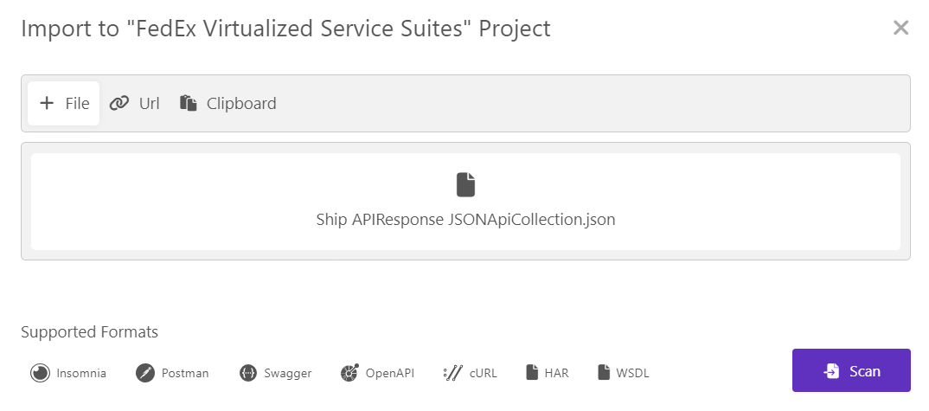

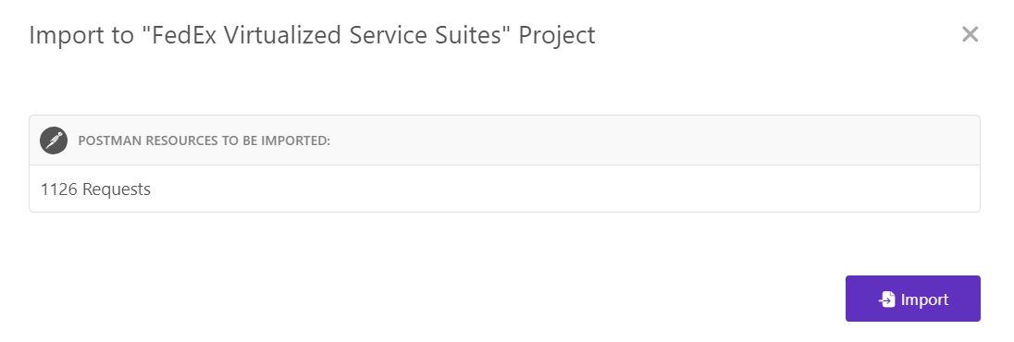

* **Step 5:** Apply filter based on *Key* that you found in Step 3 from the “*Lookup Test case tool*” excel.

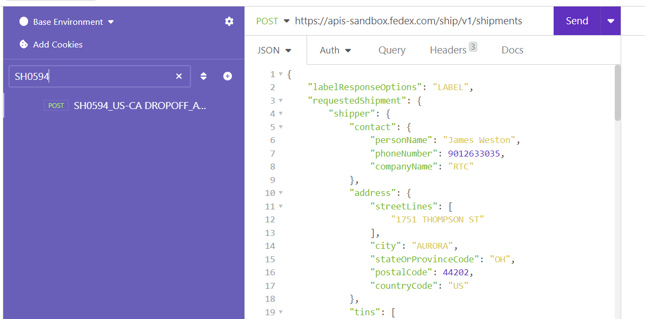

* **Step 6:** Run this sample transaction once you have token added into the header.